District Attorney’s Crime Lab

Youth Shadow Day
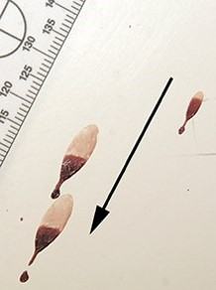
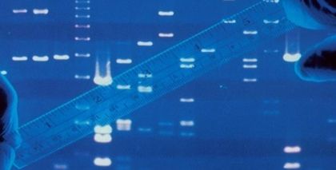
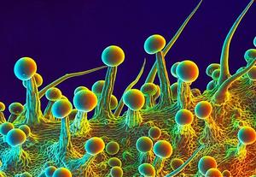

FROM THE CRIME SCENE TO THE COURTROOM
Meet Criminalists that are experts in the various fields of forensic science

- Learn the importance of evidence preservation and chain of custody
- Observe bullet trajectory and presumptive blood testing
- Review crime scene investigations and see a real drug chemistry display
- Experience how TRACE cases are examined

WHEN: Two Friday Dates: July 16, 2021, or July 23, 2021
WHERE: Virtually – broadcasted live from the crime lab
TIME: 10:00 AM to 11:30 AM

Open to current Sacramento County high school students. Priority will be given to senior high school students.

Space is limited to 60 students each session and on a first come, first served basis. Please register early.

Students will need to submit completed registration forms and a signed permission slip, which can be downloaded at www.sacda.org.

The deadline to apply is July 2, 2021

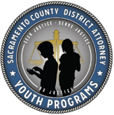
For questions, please email YouthPrograms@sacda.org

