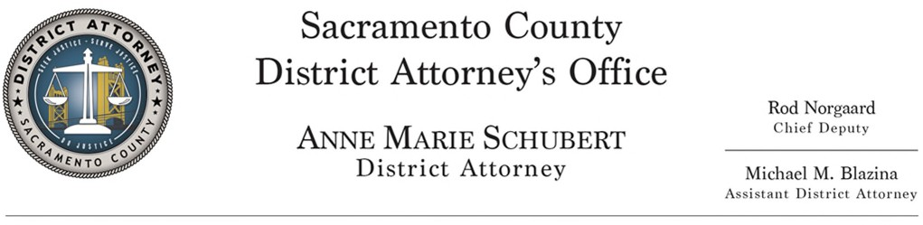

2021 Crime Lab Youth Shadow Day Registration Form

Registration deadline is July 2, 2021
Accepted on first come, first served basis, limited to 60 students per session.

Seniors receive priority
To apply, please fill out the information below and email it to youthprograms@sacda.org with a signed permission slip from your parent/guardian:

Name: DOB:

Address:

Email Address:

Phone: School: Grade:

Gender: Female Male

Parent/Guardian:

Parent/Guardian Phone: Email:

Prior participation in one of our Youth Programs? If so, which one:

How did you learn about our Crime Lab Youth Shadow Day?

Two dates to choose from July 16, 2021 and July 23, 2021

Date Selected:
Friday, July 16, 2021 or
Friday, July 23, 2021

On a separate sheet of paper please write a paragraph answering the following question:

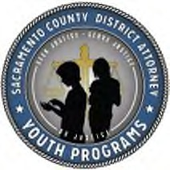
1. Why do you want to participate in the Crime Lab Shadow Day?

Applications and original permission slips should be scanned and emailed to:

youthprograms@sacda.org

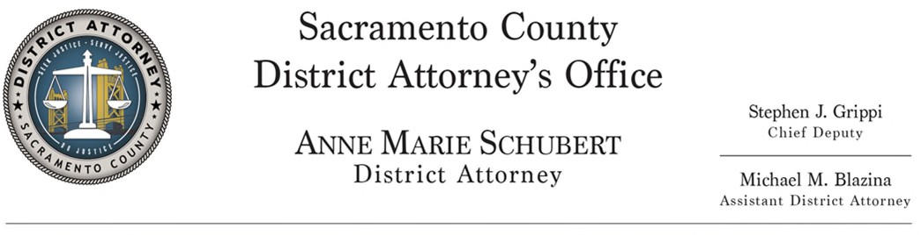

PARENT/GUARDIAN STATEMENT OF CONSENT

2021 CRIME LAB SHADOW DAY

Please Choose One:

Friday, July 16, 2021 or Friday, July 23, 2021

I hereby give consent to my child to participate in the Sacramento County District Attorney’s Office, Crime Lab Youth Shadow Day (CLYSD).

I understand that this will be a virtual tour and my child will be participating with designated employees from the participating county agencies.

I understand that this event will be broadcasted live on social media and my student’s participation and interaction may also be shared on social media.

I understand and agree that during the course of this event my student’s comments and questions may be used on the District Attorney’s web and social media sites to promote education programs.

I understand that any shadowing that takes place within the Sacramento County Crime Lab may include observation of evidence regarding serious criminal cases.

I consent, to all of the above, for
Student’s Name (Print)

Authorized by:
Signature of parent/guardian Date

