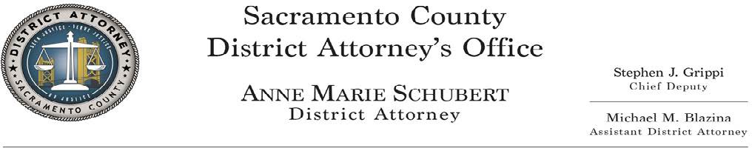

REQUEST FOR CONVICTION REVIEW
The Justice, Training, and Integrity Unit of the Sacramento County District Attorney’s Office will review cases that meet the following criteria:

The conviction must arise from a Sacramento County case;
- A claim must not be frivolous;

Records/evidence necessary for re-investigation must be available for review;
- The applicant must present a new and credible claim of actual innocence or wrongful conviction. Particular attention will be given to newly discovered evidence or evidence supporting wrongful conviction due to issues concerning forensic science, misidentification, misconduct or Brady/discovery violations, jail/confidential informant, alibi and witness recantation. (Post-Conviction DNA testing must be requested pursuant to Penal Code section 1405, but results of such testing may result in internal referral for conviction review);

The applicant and/or convicted person must fully and openly cooperate with the unit. If applicant has an attorney, all communication must be made through the attorney.

JTI will NOT review the following and these cases may be summarily dismissed upon screening:

Purely ineffective assistance of counsel claims;
Claims regarding procedural errors at trial or purely legal claims; Other “general” writ claims (such as time credits calculations, etc.).

A plea of guilty is not a bar to review, but will be subjected to a higher level of scrutiny. Capital Murder, Murder, Sexual Assault, or other serious felonies where the convicted is in custody and serving a substantial sentence will be given priority.

Decisions regarding whether JTI will re-open case investigations, as well as how the claim will be investigated and resolved, are at the discretion of the Sacramento County District Attorney’s Office.

Information Required: Defendants or their representative must complete and submit the form below (use additional pages if needed):

Defendant’s name: Date of birth: X-Ref or CDCR Number: Contact information:

If submitted by another on behalf of Defendant, list your relationship to Defendant and your name and contact information:

If this request is being submitted by someone other than the person convicted, have you obtained the written consent of the person convicted to file this request? Yes ☐ No ☐
Correctional facility where defendant is housed:

Sacramento County Superior Court Case Number:

List the crimes of conviction:

Date of Conviction:

Was the conviction by jury trial, court trial, plea of guilty, or by plea of nolo contendere?

Length of Sentence imposed:

Who was your attorney at trial?

Was there a direct appeal? Yes ☐ No ☐
If yes, who was your attorney?
If yes, please list the appellate case number:
If yes, please list the date the appeal was filed: If yes, are there any proceedings still currently pending? Yes ☐ No ☐
If there are no pending proceedings, please list date decided (i.e. the date the opinion was issued or mandate was returned):

Were there any State or Federal Writs filed in the case? Yes ☐ No ☐
If yes, who was your attorney?
If yes, please list the Habeas Corpus case number: If yes, are there any proceedings still currently pending? Yes ☐ No ☐
If there are no pending proceedings, please list date decided (i.e. the date the opinion was issued or mandate was returned):

Was there a request for post-conviction DNA testing? Yes ☐ No ☐
If yes, who was your attorney?
If yes, are there any proceedings still currently pending? Y Yes ☐ No ☐
If yes, was any testing done? Yes ☐ No ☐
List what evidence was tested and any results:

- - - - - - - - - - - - - - - - - - - - - - - - - - - - - - - - - - - - - - - - - - - - - - - - - - - -

Describe your claim of innocence or wrongful conviction:

What issues (as described above in the instruction sheet) are present in your case, if any?

What evidence supports your claims? (Include any alibi, other suspects, physical evidence such as weapon, examined or unexamined forensic evidence such as DNA or fingerprints, etc.)

Provide any other information you think would be helpful in reviewing your case. Include information (name, phone numbers, addresses, and email) for any persons you think could provide information that could assist in your claims or verify any of the information you provided.

Attach copies of any relevant documents that support the defendant’s claim of innocence (affidavits of new witnesses, new scientific test results, etc.) and any other information that would assist in verifying the claim of innocence or wrongful conviction. Do not send original documents.

Signature of person submitting this request:

Dated:

Return the completed Request for Conviction Review form and all other requested documentation to the following address via US Mail or email:

Sacramento County District Attorney’s Office Justice, Training and Integrity Unit
901 G Street
Sacramento, CA 95814 daoffice@sacda.org

