District Attorney’s Crime Lab

Youth Shadow Day
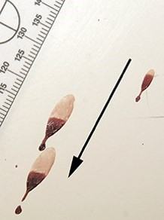
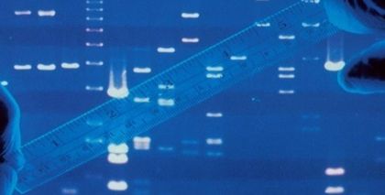
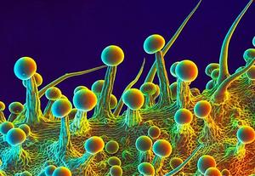

FROM THE CRIME SCENE TO THE COURTROOM
Meet Criminalists that are experts in the various fields of forensic science

- Learn the importance of evidence preservation and chain of custody
- Observe bullet trajectory and presumptive blood testing
- Review crime scene investigations and see a real drug chemistry display
- Experience how TRACE cases are examined

WHEN: Two Dates: Friday, July 17, 2020 or July 24, 2020
WHERE: Virtually – broadcasted live from the crime lab
TIME: 10:00 AM to 11:30 AM

Open to current Sacramento County high school students. Priority will be given to senior high school students.

Space is limited to 60 students each session and on a first come, first served basis. Please register early.

Students will need to submit completed registration forms and a signed permission slip, which can be downloaded at www.sacda.org.

The deadline to apply is July 10, 2020

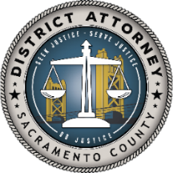
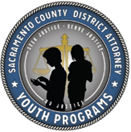
For questions, please email YouthPrograms@sacda.org

